What’s a Key Lookup?

Author: Monica Rathbun
https://sqlespresso.com/2019/04/03/whats-a-key-lookup/
- One of the easiest things to fix when performance tuning queries are Key Lookups or RID Lookups.
- The key lookup operator occurs when the query optimizer performs an index seek against a specific table and that index does not have all the columns needed to fulfil the result set.
- SQL Server is forced to go back to the clustered index using the Primary Key and retrieve the remaining columns it needs to satisfy the request.
- A RID lookup is the same operation but is performed on a table with no clustered index, otherwise known as a heap. It uses a row id instead of a primary key to do the lookup.
- As you can see these can very expensive and can result in substantial performance hits in both I/O and CPU.
- Imagine a query that runs thousands of times per minute that includes one or more key lookups.
- This can result in tremendous overhead which is generated by these extra reads it effects the overall engine performance.
Let’s look at an example.
SELECT [SalesOrderID],[CarrierTrackingNumber],[OrderQty],[ProductID],
[UnitPrice],[ModifiedDate];
FROM [AdventureWorks2014].[Sales].[SalesOrderDetail];
Where [ModifiedDate]> '2014/01/01'; and [ProductID]=772
- The cost of the key lookup operator is 99% of the query.
- We can see it did an Index Seek to the IX_SalesOrderDetail_ProductID which is very effective, but that index did not have all the columns needed to satisfy the query.
- The optimizer then went out to the clustered index PK_SalesOrderDetail_SalesOrderID_SalesOrderDetailID to retrieve the additional columns it needed.
- We can see what it got by hovering over the key lookup in the query plan window.
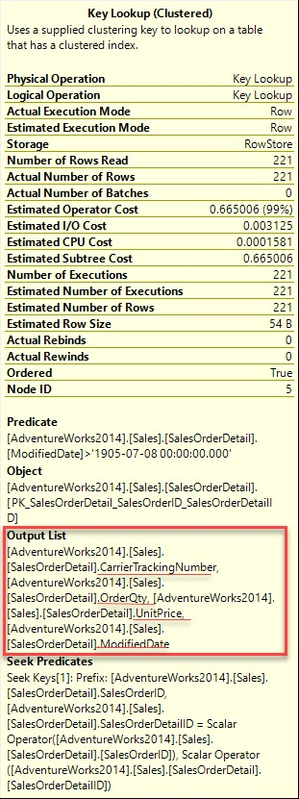

- The good thing about Key and RID look ups is that they are super easy to fix.
- With a little modification to the non-clustered Index IX_SalesOrderDetail_ProductID we can change to query plan from an Index Seek and a Key Lookup to a very small index seek.
- All we have to do is recreate that index & add the Output List fields as Included columns on that index.
CREATE NONCLUSTERED INDEX [IX_SalesOrderDetail_ProductID]
ON [Sales].[SalesOrderDetail]([ProductID] ASC)
INCLUDE ([CarrierTrackingNumber],[UnitPrice], [ModifiedDate], [OrderQty])
WITH (PAD_INDEX = OFF, STATISTICS_NORECOMPUTE = OFF, SORT_IN_TEMPDB = OFF, DROP_EXISTING = ON, ONLINE = OFF, ALLOW_ROW_LOCKS = ON, ALLOW_PAGE_LOCKS = ON)
ON [PRIMARY]
- And as you can see, we now have an Index Seek only and a more efficient plan.
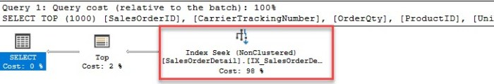
- Key Lookups can cause performance headaches, especially for queries that run many times a day.
- Do yourself and your environment a favor and start hunting these down and get them fixed.
- Jonathan Kehayias (B|T) has a great blog on how to locate theses in plan cache be sure to check it out.

https://www.sqlskills.com/blogs/jonathan/finding-key-lookups-inside-the-plan-cache/

Author: https://sqlespresso.com/about-me/

